Team-1

Team name - DTU Supermileage

University- Delhi technological University, New Delhi

Sponsor- Maruti Suzuki Service Masters for the paintjob, CFW enterprises for the bodywork, GAIL, AvoirMask,

PCRA, BlazeFlash Couriers limited, Pioneer Filmed,

Contact- 099715 97933

[Mail- supermileage@dce.ac.in](mailto:Mail-%20supermileage@dce.ac.in)

Website- dtusupermileage.blogspot.in/

Team-2

Team Name- TeamBits

Institute- BITS, Pilani

Sponsors- Aditya Birla Group, Panasonic, Ricardo, CFW enterprises, Shriram group, Amplus Solar, SKF group

Achievements- In the latest 33rd season of the event, held in Singapore, March 2017 the team presented The Tapas, with an ethanol based engine. It is the first that time any student team from India built an ethanol-based vehicle and fabricate an entire Carbon Fibre body.

For these feats the team was felicitated with a Special Recognition Award and a cash Prize of INR 2,00,000 by Mr. Nitin Prasad, Chairman, Shell Companies India at the Shell Technology Centre Bangalore in March 2017. Also, the team got to present the vehicle and interact with Shri. Dharmendra Pradhan, Hon’ble Minister for Petroleum and Natural Gas, Govt of India, Shri. R.V. Deshpande, Hon’ble Minister for Industries, Govt. of Karnataka and many experts from the energy and automotive industry.

Call 095494 82846

Website- <http://www.team-bits.com/>

Mail- [teambits.semasia@gmail.com](mailto:teambits.semasia@gmail.com)

Team-3

Team Name- Team Averera

Institute- Indian Institute of Technology - Banaras Hindu University, Varanasi, India

Sponsor- Nike Energy Manufacturing Limited is an India-based company, a pioneer in the field of manufacturing power transmission line tools & plants and hardware fittings. JK Tyre, Bansal Suzuki, mam computers, NIMESH,

Achievements- Solar Indica

Title Sponsor: Center for Energy and Resources Development

Mail – [teamaverera@gmail.com](mailto:teamaverera@gmail.com)

Website- [www.teamaverera.com](http://www.teamaverera.com)

Team-4

Team Name- Team Kaizen

University- Pandit Deendayal Petroleum University, Gandhinagar

Sponsors- PDPU, Gujarat Tourism, Rudra TMX, The Industrial Development and Co pvt ltd.

Mail- [teamkaizenindia@gmail.com](mailto:teamkaizenindia@gmail.com)

Website- [www.teamkaizenindia.com](http://www.teamkaizenindia.com)

Team-5

Team Name- Team Eco Titans

University – VIT university, Vellore

Sponsors-

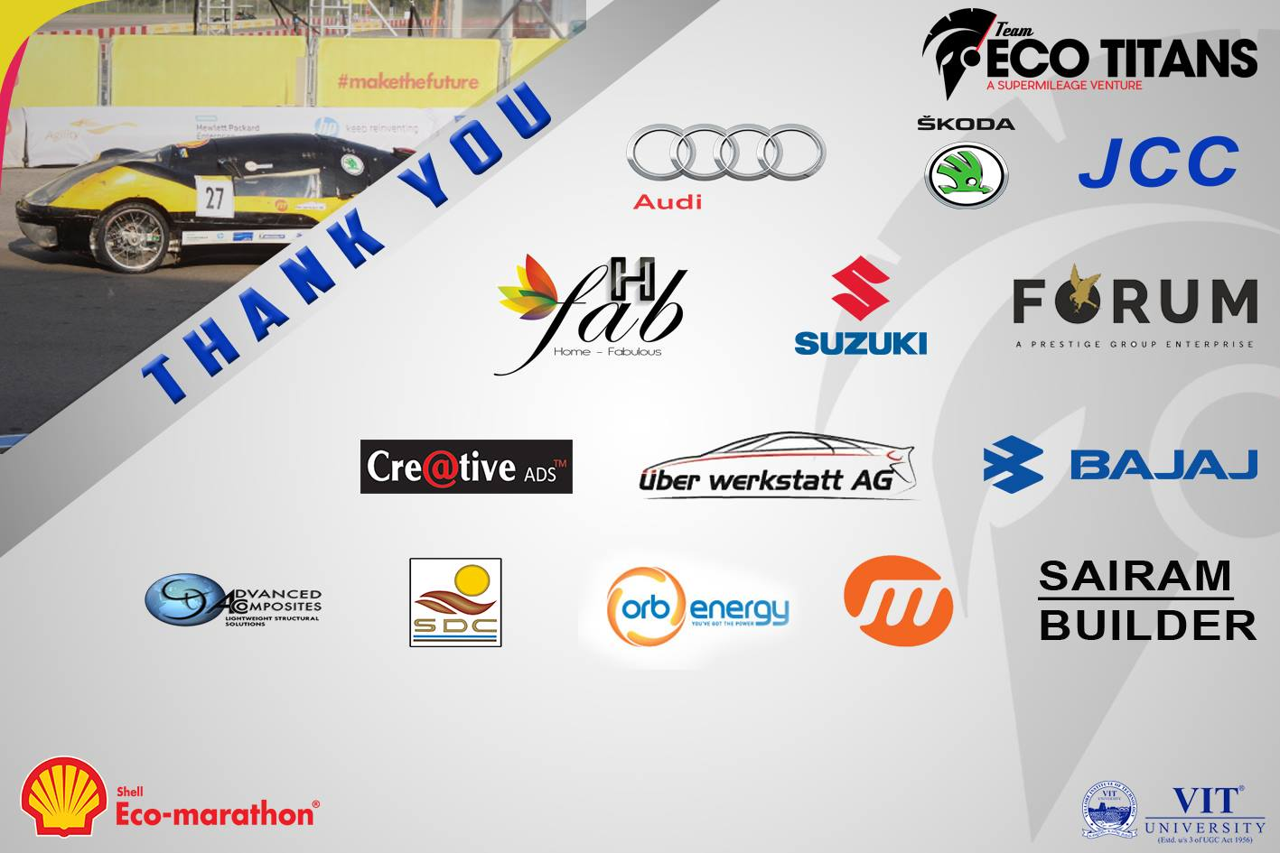

Mail- [teamecotitans@gmail.com](mailto:teamecotitans@gmail.com)

Website- <http://teamecotitans.blogspot.in/>

Team-6

Team Name- Infieon SuperMileage

University- SRM University, Chennai

Sponsors- SHELL, HONDA motorcycles and scooters, U T H, TPT the productivity team, Just buy cycles

Mail- info@infieonsupermileage.com

Website- <http://www.infieonsupermileage.com/>